Name: Trinetra Naga Sai
Reg.no:24BCT0198

1st question:

<!DOCTYPE html>
<html>
<head>
<meta charset="UTF-8" />
<title>1st question </title>
</head>
<body>
<table border="1">
<tbody>
<tr style="background-color:lightgrey;">
<th rowspan="2">THEORY</th>
<th>Start</th>
<th>08:00</th>
<th>09:00</th>
<th>10:00</th>
<th>11:00</th>
<th>12:00</th>
<th>-</th>
<th>Lunch</th>
<th>14:00</th>
<th>15:00</th>
<th>16:00</th>
<th>17:00</th>
<th>18:00</th>
<th>18:51</th>
<th>19:01</th>
</tr>
<tr style="background-color:lightgrey;">
<th>End</th>
<th>08:50</th>
<th>09:50</th>
<th>10:50</th>
<th>11:50</th>
<th>12:50</th>
<th>-</th>
<th>Lunch</th>
<th>14:50</th>
<th>15:50</th>
<th>16:50</th>
<th>17:50</th>
<th>18:50</th>
<th>19:00</th>
<th>19:50</th>
</tr>
<tr style="background-color:lightgrey;">
<th rowspan="2">LAB</th>
<th>Start</th>
<th>08:00</th>
<th>08:51</th>
<th>09:51</th>
<th>10:41</th>
<th>11:40</th>
<th>12:31</th>
<th>Lunch</th>
<th>14:00</th>
<th>14:51</th>
<th>15:51</th>
<th>16:41</th>
<th>17:40</th>
<th>18:31</th>
<th>-</th>
</tr>
<tr style="background-color:lightgrey;">
<th>End</th>
<th>08:50</th>
<th>09:40</th>
<th>10:40</th>
<th>11:30</th>
<th>12:30</th>
<th>13:20</th>
<th>Lunch</th>
<th>14:50</th>
<th>15:40</th>
<th>16:40</th>
<th>17:30</th>
<th>18:30</th>
<th>19:20</th>
<th>-</th>
</tr>
<tr>
<th rowspan="2" style="background-color:lightgrey;">MON</th>
<th style="background-color:lightgrey;">THEORY</th>
<th>A1</th>
<th>F1</th>
<th>D1</th>
<th>TB1</th>
<th>TG1</th>
<th>-</th>
<th style="background-color:lightgrey;">Lunch</th>
<th style="background-color:#ffcccc;">A2-BCSE205L-TH-PRP204-ALL</th>
<th style="background-color:#ffcccc;">F2-BCSE204L-TH-PRP308-ALL</th>
<th style="background-color:#ffcccc;">D2-BSTS102P-SS-PRP223-ALL</th>
<th style="background-color:#ffcccc;">TB2-BMAT202L-TH-PRP207-ALL</th>
<th>TG2</th>
<th>-</th>
<th>V3</th>
</tr>
<tr>
<th style="background-color:lightgrey;">LAB</th>
<th>L1</th>
<th>L2</th>
<th style="background-color:#ffcccc;">L3-BMAT202P-LO-PRP450-ALL</th>
<th style="background-color:#ffcccc;">L4-BMAT202P-LO-PRP450-ALL</th>
<th style="background-color:#ffcccc;">L5-BCSE203E-ELA-PRP137-ALL</th>
<th style="background-color:#ffcccc;">L6-BCSE203E-ELA-PRP137-ALL</th>
<th style="background-color:lightgrey;">Lunch</th>
<th>L31</th>
<th>L32</th>
<th>L33</th>
<th>L34</th>
<th>L35</th>
<th>L36</th>
<th>-</th>
</tr>
<tr>
<th rowspan="2" style="background-color:lightgrey;">TUE</th>
<th style="background-color:lightgrey;">THEORY</th>
<th>B1</th>
<th>G1</th>
<th>E1</th>
<th>TC1</th>
<th>TAA1</th>
<th>-</th>
<th style="background-color:lightgrey;">Lunch</th>
<th style="background-color:#ffcccc;">B2-BMAT202L-TH-PRP207-ALL</th>
<th style="background-color:#ffcccc;">G2-BESP101L-TH-SJTG14-ALL</th>
<th style="background-color:#ffcccc;">E2-BCSE304L-TH-PRP309-ALL</th>
<th style="background-color:#ffcccc;">TC2-BECE204L-TH-PRP318-ALL</th>
<th style="background-color:#ffcccc;">TAA2-BCSE203E-ETH-PRP219-ALL</th>
<th>-</th>
<th>V4</th>
</tr>
<tr>
<th style="background-color:lightgrey;">LAB</th>
<th>L7</th>
<th>L8</th>
<th>L9</th>
<th>L10</th>
<th>L11</th>
<th>L12</th>
<th style="background-color:lightgrey;">Lunch</th>
<th>L37</th>
<th>L38</th>
<th>L39</th>
<th>L40</th>
<th>L41</th>
<th>L42</th>
<th>-</th>
</tr>
<tr>
<th rowspan="2" style="background-color:lightgrey;">WED</th>
<th style="background-color:lightgrey;">THEORY</th>
<th>C1</th>
<th>A1</th>
<th>F1</th>
<th>V1</th>
<th>V2</th>
<th>-</th>
<th style="background-color:lightgrey;">Lunch</th>
<th style="background-color:#ffcccc;">C2-BECE204L-TH-PRP318-ALL</th>
<th style="background-color:#ffcccc;">A2-BCSE205L-TH-PRP204-ALL</th>
<th style="background-color:#ffcccc;">F2-BCSE204L-TH-PRP308-ALL</th>
<th style="background-color:#ffcccc;">TD2-BSTS102P-SS-PRP223-ALL</th>
<th>TBB2</th>
<th>-</th>
<th>V5</th>
</tr>
<tr>
<th style="background-color:lightgrey;">LAB</th>
<th style="background-color:#ffcccc;">L13-BCSE203E-ELA-PRP137-ALL</th>
<th style="background-color:#ffcccc;">L14-BCSE203E-ELA-PRP137-ALL</th>
<th>L15</th>
<th>L16</th>
<th>L17</th>
<th>L18</th>
<th style="background-color:lightgrey;">Lunch</th>
<th>L43</th>
<th>L44</th>
<th>L45</th>
<th>L46</th>
<th>L47</th>
<th>L48</th>
<th>-</th>
</tr>
<tr>
<th rowspan="2" style="background-color:lightgrey;">THU</th>
<th style="background-color:lightgrey;">THEORY</th>
<th>D1</th>
<th>B1</th>
<th>G1</th>
<th>TE1</th>
<th>TCC1</th>
<th>-</th>
<th style="background-color:lightgrey;">Lunch</th>
<th style="background-color:#ffcccc;">D2-BSTS102P-SS-PRP223-ALL</th>
<th style="background-color:#ffcccc;">B2-BMAT202L-TH-PRP207-ALL</th>
<th style="background-color:#ffcccc;">G2-BESP101L-TH-SJTG14-ALL</th>
<th style="background-color:#ffcccc;">TE2-BCSE304L-TH-PRP309-ALL</th>
<th>TCC2</th>
<th>-</th>
<th>V6</th>
</tr>
<tr>
<th style="background-color:lightgrey;">LAB</th>
<th>L19</th>
<th>L20</th>
<th style="background-color:#ffcccc;">L21-BCSE204P-LO-PRP233-ALL</th>
<th style="background-color:#ffcccc;">L22-BCSE204P-LO-PRP233-ALL</th>
<th>L23</th>
<th>L24</th>
<th style="background-color:lightgrey;">Lunch</th>
<th>L49</th>
<th>L50</th>
<th>L51</th>
<th>L52</th>
<th>L53</th>
<th>L54</th>
<th>-</th>
</tr>
<tr>
<th rowspan="2" style="background-color:lightgrey;">FRI</th>
<th style="background-color:lightgrey;">THEORY</th>
<th>E1</th>
<th>C1</th>
<th>TA1</th>
<th>TF1</th>
<th>TD1</th>
<th>-</th>
<th style="background-color:lightgrey;">Lunch</th>
<th style="background-color:#ffcccc;">E2-BCSE304L-TH-PRP309-ALL</th>
<th style="background-color:#ffcccc;">C2-BECE204L-TH-PRP318-ALL</th>
<th style="background-color:#ffcccc;">TA2-BCSE205L-TH-PRP204-ALL</th>
<th style="background-color:#ffcccc;">TF2-BCSE204L-TH-PRP308-ALL</th>
<th>TDD2</th>
<th>-</th>
<th>V7</th>
</tr>
<tr>
<th style="background-color:lightgrey;">LAB</th>
<th>L25</th>
<th>L26</th>
<th>L27</th>
<th>L28</th>
<th style="background-color:#ffcccc;">L29-BECE204P-LO-PRP135-ALL</th>
<th style="background-color:#ffcccc;">L30-BECE204P-LO-PRP135-ALL</th>
<th style="background-color:lightgrey;">Lunch</th>
<th>L55</th>
<th>L56</th>
<th>L57</th>
<th>L58</th>
<th>L59</th>
<th>L60</th>
<th>-</th>
</tr>
<tr>
<th rowspan="2" style="background-color:lightgrey;">SAT</th>
<th style="background-color:lightgrey;">THEORY</th>
<th>V8</th>
<th>X11</th>
<th>X12</th>
<th>Y11</th>
<th>Y12</th>
<th>-</th>
<th style="background-color:lightgrey;">Lunch</th>
<th>X21</th>
<th>Z21</th>
<th>Y21</th>
<th>W21</th>
<th>W22</th>
<th>-</th>
<th>V9</th>
</tr>
<tr>
<th style="background-color:lightgrey;">LAB</th>
<th>L71</th>
<th>L72</th>
<th>L73</th>
<th>L74</th>
<th>L75</th>
<th>L76</th>
<th style="background-color:lightgrey;">Lunch</th>
<th>L77</th>
<th>L78</th>
<th>L79</th>
<th>L80</th>
<th>L81</th>
<th>L82</th>

</tr>
<tr>
<th rowspan="2" style="background-color:lightgrey;">SUN</th>
<th style="background-color:lightgrey;">THEORY</th>
<th>V10</th>
<th>Y11</th>
<th>Y12</th>
<th>X11</th>
<th>X12</th>
<th>-</th>
<th style="background-color:lightgrey;">Lunch</th>
<th>Y21</th>
<th>Z21</th>
<th>X21</th>
<th>W21</th>
<th>W22</th>
<th>-</th>
<th>V11</th>
</tr>
<tr>
<th style="background-color:lightgrey;">LAB</th>
<th>L83</th>
<th>L84</th>
<th>L85</th>
<th>L86</th>
<th>L87</th>
<th>L88</th>
<th style="background-color:lightgrey;">Lunch</th>
<th>L89</th>
<th>L90</th>
<th>L91</th>
<th>L92</th>
<th>L93</th>
<th>L94</th>
<th>-</th>
</tr>
</tbody>
</table>
</body>
</html>
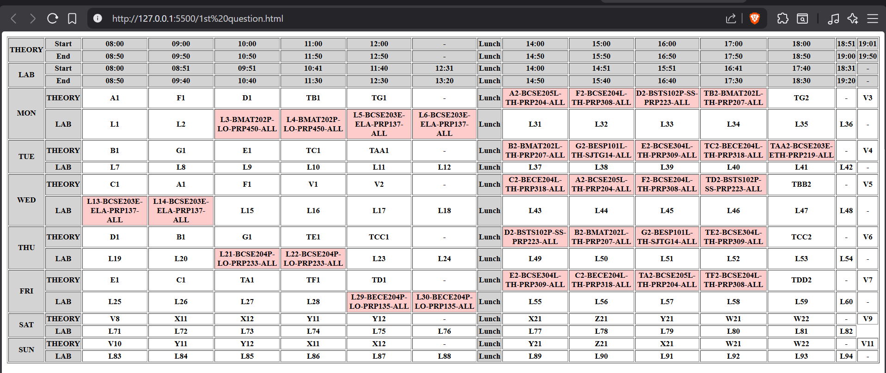
2nd question:
<!DOCTYPE html>
<html lang="en">
<head>
<meta charset="UTF-8">
<meta name="viewport" content="width=device-width, initial-scale=1.0">
<title>2nd question </title>
</head>
<body>
<title>
time table
</title>
<table border="1">

<tr>
<th rowspan="2">
Name of train
</th>
<th rowspan="2">
Place
</th>
<th rowspan="2">
Destination
</th>
<th rowspan="2">
Train No
</th>
<th colspan="2">
Time
</th>

<th rowspan="2">
Fair
</th>

</tr>
<tr>
<th>
Arrival
</th>
<th>
Depature
</th>
</tr>

<tr>
<td>Godavari SF Express</td>
<td>Hyderabad </td>
<td>Vijayawada</td>
<td>12728</td>
<td>22:30</td>
<td>17:05</td>
<td>₹400</td>
</tr>

<tr>
<td>LPI Intercity Express</td>
<td>Vijayawada</td>
<td>Secunderabad / Hyderabad </td>
<td>12795</td>
<td>22:10</td>
<td>17:30</td>
<td>₹150 </td>
</tr>

<tr>
<td>Golconda Express</td>
<td>Vijayawada </td>
<td>Hyderabad </td>
<td>17201</td>
<td>13:55</td>
<td>07:00</td>
<td>₹140 </td>
</tr>

<tr>
<td>Konark Express</td>
<td>Vijayawada </td>
<td>Hyderabad </td>
<td>11020</td>
<td>10:50</td>
<td>04:55</td>
<td>₹610 </td>
</tr>

<tr>
<td>Charminar SF Express</td>
<td>Vijayawada </td>
<td>Hyderabad </td>
<td>12759</td>
<td>06:35</td>
<td>01:00</td>
<td>₹255 </td>
</tr>

<tr>
<td>Garib Rath </td>
<td>Hyderabad </td>
<td>Vijayawada </td>
<td>12739 / 12740 </td>
<td>01:40</td>
<td>20:30</td>
<td>₹495 </td>
</tr>

<tr>
<td>Goutami SF Express</td>
<td>Vijayawa</td>
<td>Hyderabad </td>
<td>12737</td>
<td>04:35</td>
<td>22:40</td>
<td>₹255 </td>
</tr>

<tr>
<td>SMVT Bengaluru – Tirupati Express</td>
<td>Bengaluru </td>
<td>Tirupati </td>
<td>18638 </td>
<td>21:00</td>
<td>00:15</td>
<td>₹200 </td>
</tr>

<tr>
<td>BZA Intercity </td>
<td>Vijayawada </td>
<td>Secunderabad </td>
<td>12796</td>
<td>10:45</td>
<td>05:30</td>
<td>₹145 </td>
</tr>

<tr>
<td>Kaveri express </td>
<td>Bengaluru</td>
<td>chennai</td>
<td>16022</td>
<td>11:50</td>
<td>6:45 </td>
<td>₹775 </td>
</tr>
</body>
</html>

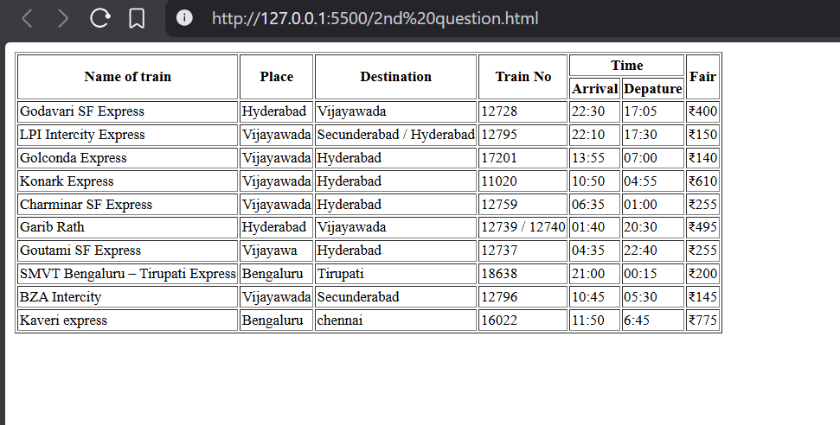

3rdquestion:
<!DOCTYPE html>
<html lang="en">
<head>
<meta charset="UTF-8">
<meta name="viewport" content="width=device-width, initial-scale=1.0">
<title>3rd question</title>
</head>
<body>
<table border="1">
<thead>
<tr>
<th>
Course Number
</th>
<th>
Course Title
</th>
<th>
Semester Taken
</th>
</tr>
<tr>
<th colspan="3">
For Credit
</th>
</tr>
</thead>
<tbody>
<tr>
<td>
6.813
</td>
<td>
User Interface Design
</td>
<td>
Spring 2014
</td>
</tr>
<tr>
<td>
6.034
</td>
<td>
Artifical intellagance
</td>
<td>
Fall 2013
</td>
</tr>
<tr>
<td>
6.006
</td>
<td>
Introduction to Alogorathims
</td>
<td>
Fall 2013
</td>
</tr>
</tbody>
<thead style="width: 2000px;">
<tr >
<th colspan="3">
Listener
</th>
</tr>
</thead>
<tbody>
<tr>
<td>
6.867
</td>
<td>
Meachine learning
</td>
<td>
Fall 2013
</td>
</tr>
<tr>
<td>
6.830
</td>
<td>
Database System
</td>
<td>
Fall 2012
</td>
</tr>
</tbody>
</table>
</body>
</html>
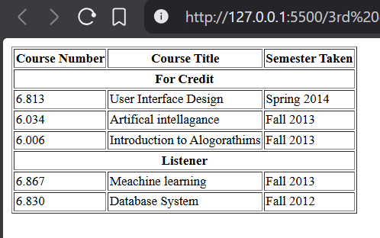
4th question:
<!DOCTYPE html>
<html lang="en">
<head>
<meta charset="UTF-8">
<meta name="viewport" content="width=device-width, initial-scale=1.0">
<title>4th question</title>
</head>
<body>
<table border="1" >
<tr>
<th rowspan="2" colspan="2">Student</th>
<th colspan="4">Exam</th>
<th colspan="4">2nd Exam</th>
<th rowspan="2" colspan="2">Final Exam</th>
</tr>
<tr>
<th>Q1</th>
<th>Q2</th>
<th>Q3</th>
<th rowspan="2">Grade</th>
<th>Q1</th>
<th>Q2</th>
<th>Q3</th>
<th rowspan="2">Grade</th>
</tr>
<tr>
<th>Code</th>
<th>Name</th>
<th>8</th>
<th>7</th>
<th>5</th>
<th>6</th>
<th>7</th>
<th>8</th>
<th>NR</th>
<th>R</th>
</tr>
<tr>
<th>80549061</th>
<th>John</th>
<th>70%</th>
<th>100%</th>
<th>100%</th>
<th>17.6</th>
<th colspan="4"> </th>
<th>17.6</th>
<th>18</th>

</tr>
<tr>
<th>80549062</th>
<th>Mary</th>
<th>10%</th>
<th>50%</th>
<th>50%</th>
<th>6.8</th>
<th>100% </th>
<th>100%</th>
<th>50%</th>
<th>16.5</th>
<th>16.5</th>
<th>17</th>

</tr>
<tr>
<th>80549063</th>
<th>Claire</th>
<th colspan="4"> </th>
<th>50%</th>
<th>50%</th>
<th>50%</th>
<th>10.0</th>
<th>10.0</th>
<th>10</th>
</tr>
</table>
</body>
</html>
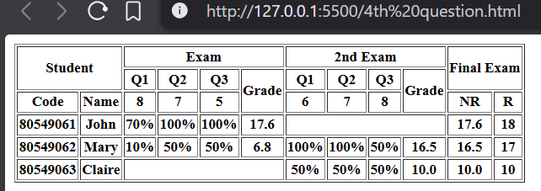
5th question :
<!DOCTYPE html>
<html lang="en">
<head>
<meta charset="UTF-8">
<meta name="viewport" content="width=device-width, initial-scale=1.0">
<title>5th question</title>
</head>
<body>
<table border=" 1" style="width:30%">
<tr>
<th rowspan="3">
A
</th>
<th colspan="3">B</th>
</tr>
<tr>
<th>E</th>
<th>f</th>
<th rowspan="2">C</th>
</tr>
<tr>
<th colspan="2">D</th>
</tr>
</table>
</body>
</html>
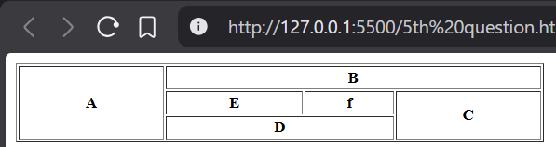
6th question:
<!DOCTYPE html>
<html lang="en">
<head>
<meta charset="UTF-8">
<meta name="viewport" content="width=device-width, initial-scale=1.0">
<title>6th question</title>
</head>
<body>
<h1>
Things That Make Me Sneeze:
</h1>
<p>
I wanted to put together quick list of stuff that mnake me sneeze.
</p>
<p>
It's because I keep forgetting to avoid these stuff amd maybe if i write it down then I'll remember
it .Particularly the one about the sawdust.
</p>
<ul>
<li>Dust</li>
<li>Ground Black Pepper</li>
<li> Doing the following</li>
<ol>
<li>
Cutting some wood using saw
</li>
<li>
Forgetting to clean the dust off
</li>
<li>
Looking at the cut real close in order to make sure that it's right
</li>
<li>
Breating in
<ul>
<li>
It's worse when I braeath in slowely amd get a real lung-full of fresh sawdust
</li>
<li>
The sawdust does smell nice.though
</li>
</ul>
</li>

</ol>

</ul>
<ul>
<li>
The next funny Item
</li>
<li>
The final ,Deeply Insightfull Item
</li>
</ul>

</body>
</html>
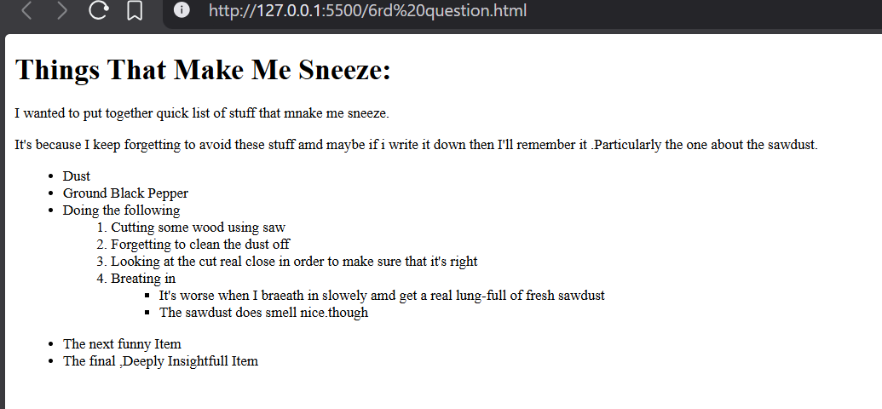
7th question:
<!DOCTYPE html>
<html lang="en">
<head>
<meta charset="UTF-8">
<meta name="viewport" content="width=device-width, initial-scale=1.0">
<title>7th question</title>
</head>
<body>
<h1>Learning Web Development</h1>
<ol type="I">
<li>
Background Skills
</li>
<ol type="A">
<li>
Unix Commands
</li>
<li>
Vim Text Editor
</li>
</ol>
<li>
HTML
</li>
<ol type="A">
<li>
Minimal Page
</li>
<li>
Headings
</li>
<li>
Tags
</li>
<li>
Lists
</li>
<ol type="i">
<li>
Unorderd
</li>
<li>
Orderd
</li>
<li>
Definition
</li>
<li>
Nested
</li>
</ol>
<li>
Links
</li>
<ol type="i">
<li>
Abosolute
</li>
<li>
Relative
</li>
</ol>
<li>
Images
</li>
</ol>
<li>
CSS
</li>
<ol type="A">
<li>
Anatomy
</li>
<li>
Basic Selectors
</li>
<ol type="i">
<li>
Elements
</li>
<li>
Class
</li>
<li>
ID
</li>
<li>
Group
</li>
</ol>
<li>
The DOM
</li>
<li>
Advanced Selectors
</li>
<li>
Box Model
</li>
</ol>
<li>
Programing
</li>
<ol type="A">
<li>
Python
</li>
<li>
JavaScript
</li>
</ol>
<li>
Database
</li>
<ol type="A">
<li>
Flat File
</li>
</ol>

</ol>
</body>
</html>
